How to Add New Level

1. Open the LevelSetup Scene.
2. Select LevelCreator gameobject.

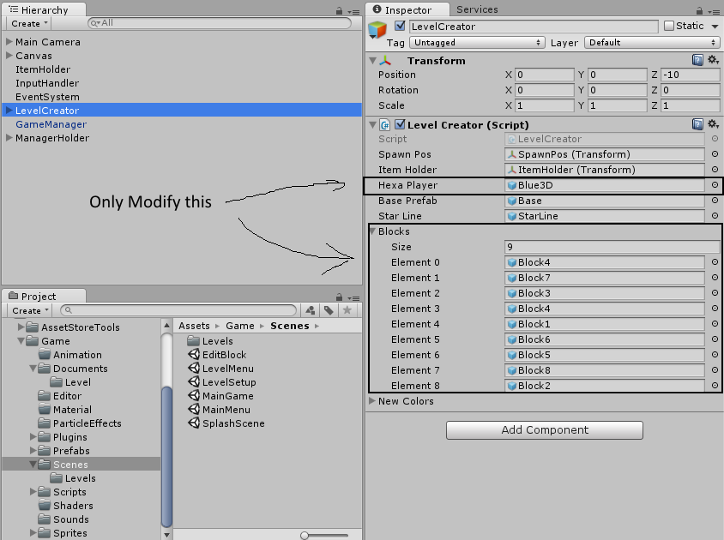

You can modify the Hexa Player and Blocks field.

The hexa player decide which hexa to spawn

The Blocks field decide which block to spawn.

The blocks are spawn according to the list , so if you want let say “Block8” to spawn 1st then you have to assign the Element 0 with Block8.

1. Once you have configured the LevelCreator then you have to save the level , save the level with name “LevelX” where X is the number like 1 ,2 ,3 etc and there must be no space between “Level” and “X”.
2. Add the level to the build.
3. Now open the LevelMenu scene , in it select the LevelScrollList .

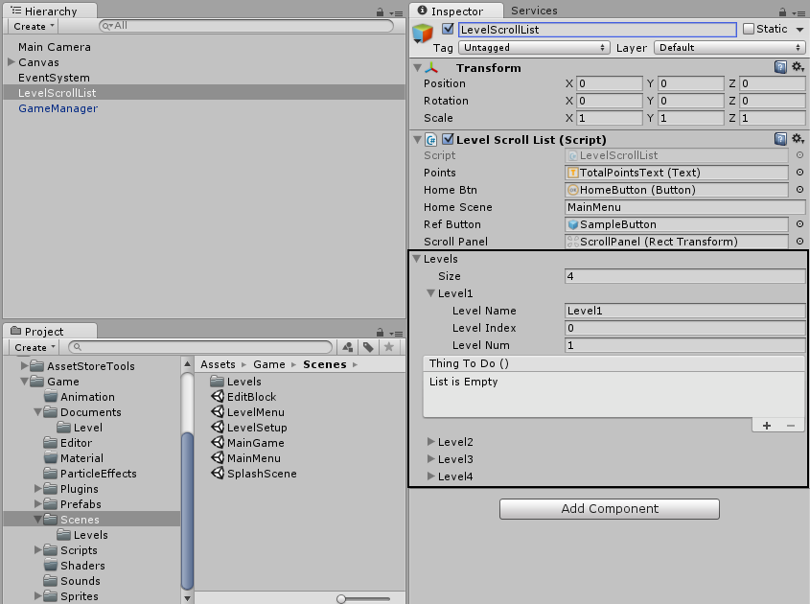

Edit the Levels field , set the “Size” , give the “Level Name” , “Level Index” and “Level Num”

Important Note:- “Level Index” is less than “Level Num” by 1 unity.

1. Then select the GameManager.

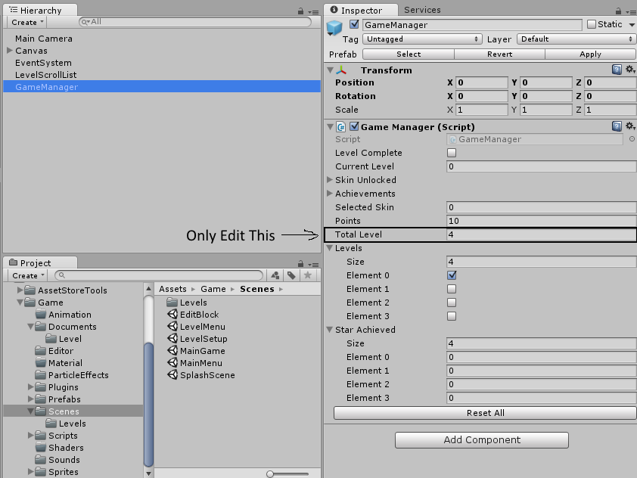

Here in “Total Level” field specify the total levels.

Click on “Reset All” and the Click on “Apply” which is at top , to save the prefab.

\*\*\*\*DONE\*\*\*\*